
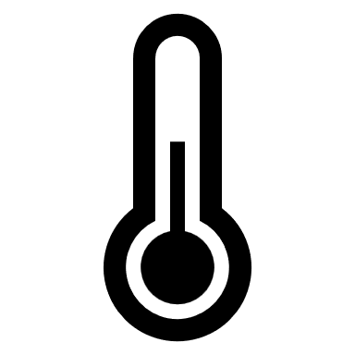
Low level lighting via spotlights

cool air
cool air
cool air
rug
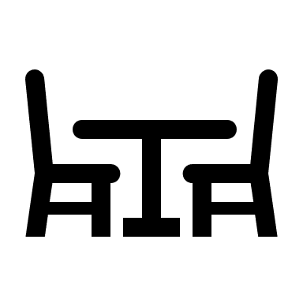


Archive Store
(not open to the public)






toys
Low level lighting via spotlights
Low level lighting via spotlights
Low level lighting via spotlights

Emergency Call Point
Call Point
Lift

Bell ringing
Dim lighting
Moving images/ silhouettes
Projected images onto walls
Images of men chatting
Sounds of men chatting

Temperature drop
Low level lighting via spotlights
Stairs
cool air
cool air
cool air
NOT
Bench

tall glass windows to the outside
Bell ringing
Dim lighting
Moving images/ silhouettes
Projected images onto walls
Images of men chatting
Sounds of men chatting

Temperature drop
Non-slip textured steps
Miners’ Chandelier (suspended from ceiling)
Interactive Screen
Textured, black, hard, sparkly path
Textured, black, hard, sparkly path
White gravel/ stones
Mine Car
Mine Car
Mine Car
Interactive game
Low level lighting via spotlights
Textured wall
Low level lighting via spotlights
Low level lighting via spotlights
Low level lighting via spotlights
Low level lighting via spotlights
Dressing up/ fiddle toys
Mine Car
Rock Layers and Map of Kent Coalfield
Lift
Stairs

